**Experiment no –01 (B)**

**Aim:** Enter the number from the user and depending on whether the number is even or odd, print out an appropriate message to the user.

**Program:**

*#***Enter the number from the user and depending on whether the number is even or odd, print out an appropriate message to the user# Python program to check if the input number is odd or even.**

**# A number is even if division by 2 gives a remainder of 0.**

**# If the remainder is 1, it is an odd number.**

**num = int(input("ENTER THE VALUE = "))**

**if (num % 2) == 0:**

**print("it is the even")**

**else:**

**print("it is the odd")**

|  |
| --- |
|  |
|  |  |
|  |  |
|  |  |
|  |  |
|  |  |

**OUTPUT:**

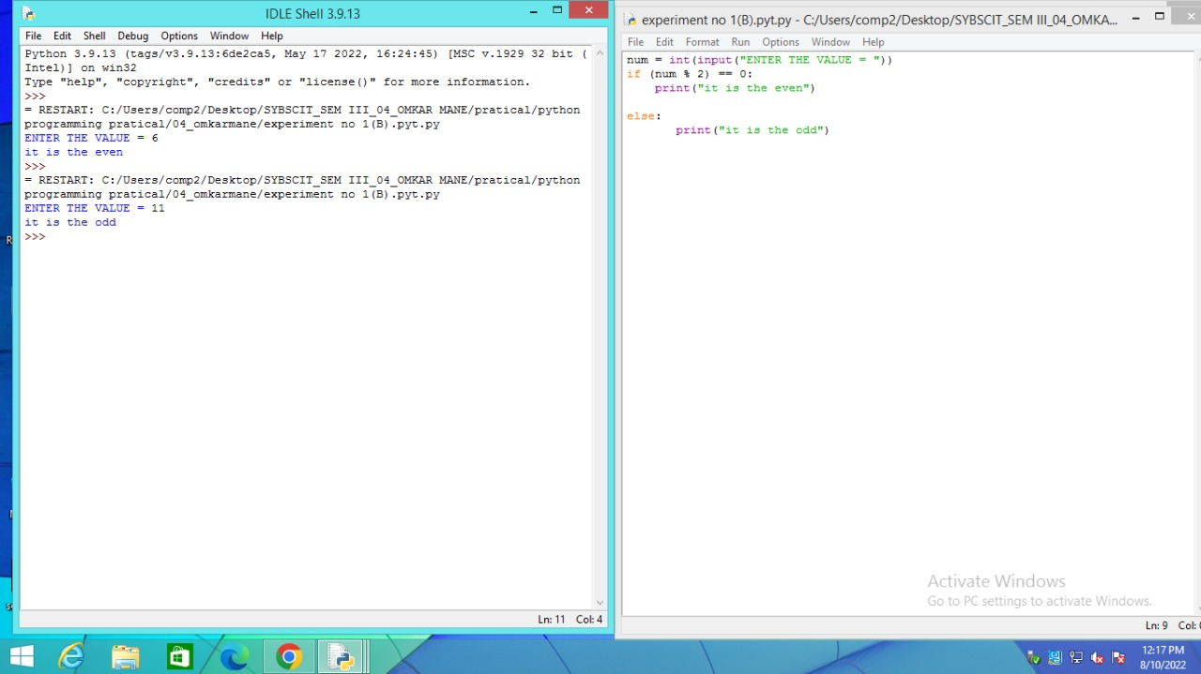

**Conclusion :** This is program successfully run.